

ITA0330-Mobile Computing
Name: -G. Akshya Reg no: -192425132
Slot: -D Course Name: -Mobile Computing

Experiment 11: Secure Mobile Application Using Figma

Aim

To create a flowchart in Figma illustrating the authentication process of a secure mobile application, including credential validation, OTP verification, and optional biometric authentication.

Procedure

- Open Figma and create a new design frame.
- Add the heading Secure Mobile Application at the top.
- Draw an oval shape and label it “Start”.
- Add rectangular boxes for opening the app and entering the username and password.
- Add a process box for system credential validation.
- Draw a diamond-shaped decision box labelled “Credentials valid?”.
- Create a “No” branch leading to an error message and retry login option.
- Create a “Yes” branch leading to OTP verification (2FA).
- Add a process box for optional biometric authentication.
- Add the final box labelled “Access Granted / Home Screen”.
- Connect all shapes using arrows and apply light blue colours.
- Align the shapes neatly and preview the completed flowchart.

Output: -
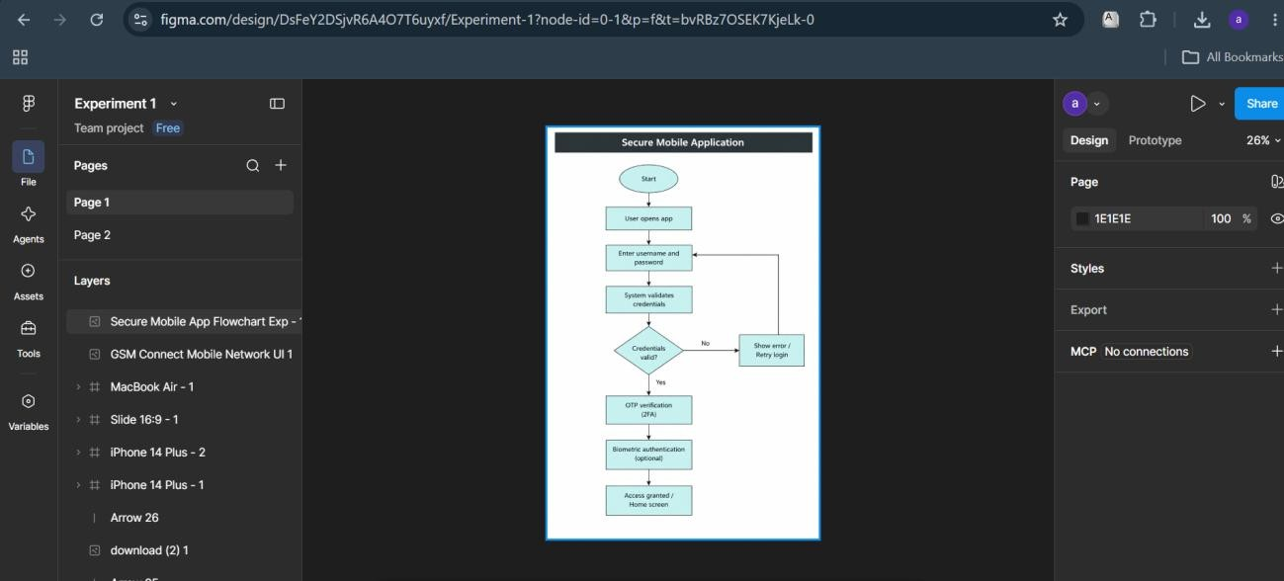

https://www.figma.com/design/DsFeY2DSjvR6A4O7T6uyxf/Experiment-1?node-id=0-1&p=f&t=bvRBz7OSEK7KjeLk-0

Result: -The secure mobile application flowchart was successfully created in Figma. It illustrates login, credential validation, error handling, OTP verification, and optional biometric authentication. The flowchart demonstrates how these steps help protect access to a mobile application.

